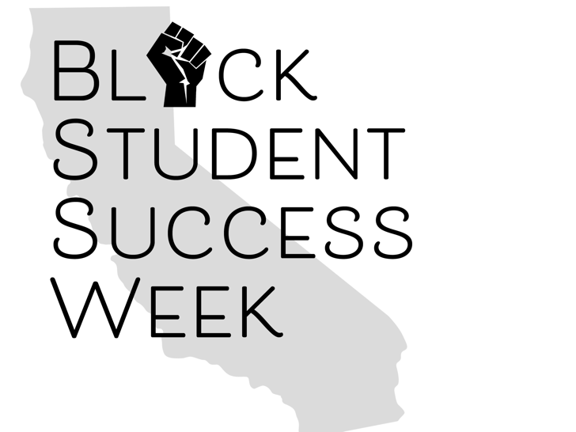

Black Student Success Week Practitioners Programming Tool Kit

**Focus on Students Activities/Events**

1. Panel with Umoja, EOPS, and/or Promise students
2. Panel with student who successfully transferred to an HBCU
3. Panel discussion with students discussing barriers and challenges remote learning.
4. Hosting Regional symposiums for students focusing on Black student success.
5. Workshop on financial matters
6. Workshop on entrepreneurship, nonprofit and for-profit organizations.
7. Student activities with Black Jeopardy music, art, etc.
8. Student event: Talent Show, rapping, painting, poetry and give out gift/Starbucks cards for participating

**Advocacy Day Activities/Events:**

1. Campus Town Hall Meeting to advocate for more funding to support Black programming (e.g. Umoja Program, HBCU Tours, Trip to Africa).
2. Workshop to teach students how to use their voice to advocate for themselves.
3. Event to engage the Associated Student Government to get them to champion Black programming on campus.
4. Highlight Black Faculty Staff association bring attention to the efforts that they are doing for Black faculty, staff, and students.

**Department of Labor Activities/Events:**

1. Career panel event that focuses on jobs that lack Black representation.
2. Community networking event to bring in Black folks from industries that lack representation
3. Career Fair in collaboration with Strong Workforce
4. Workshop to teach students how to get a jobs.
5. Creating partnerships with companies in order to create pipelines for our students to get jobs, get training, etc.
6. Teach interviewing techniques, how to invest, retirement, build credit, networking event where you bring in folks from industry
7. Workshop on financial literacy, mentorship,
8. Event to help students become aware of jobs on campus.
9. Highlighting local and regional labor data, priority sectors, etc.
10. Highlight mental health by combining mental health with mentorship and networking.
11. Coordinate Healing circles (e.g. sister to sister circles, etc.)
12. Coordinate event to share Black student employees and students stories of triumph.
13. Workshop to help students create a LinkedIn profile.
14. Workshop to talk about internships.
15. Event to bring in Fortune 500 Companies to talk about helping Black students get hired at their respective companies (Apple, Google, etc.).

**Focus Practitioners Activities/Events:**

1. Highlight programs and practices that help diversify the faculty ranks.
2. Spotlight folks that are doing the work to help campuses diversify their faculty ranks, such as RSSC Consulting.
3. Share the Black Student Success Tool Kit to help colleges expand capacity to do the work.
4. Have a Job Fair/EXPO to spotlight practitioners, Black organizations, community organizations, etc. Invite the Black media and Black newspapers.

**Focus on Faculty Activities/Events:**

1. Host a faculty luncheon
2. Highlight Black Faculty Associations
3. Acknowledge Black faculty, Black classified professionals, and Black administrators who have served their campus for 10 or more years.
4. Coordinate regional BSSW virtual watch sessions on Friday Focus on Faculty during BSSW.
5. Coordinate Black Meet and Greets to meet Black faculty members.
6. Hold workshops on campuses discussing ways to support Black faculty.
7. Have a Call to Action: What are steps that campuses can take to help Black faculty members.
8. Have a “fish bowl” session where Black faculty share actionable ways to support Black faculty.
9. Call to Action for the Chancellors Office to be intentional in their efforts to encourage campuses to hire Black faculty members.