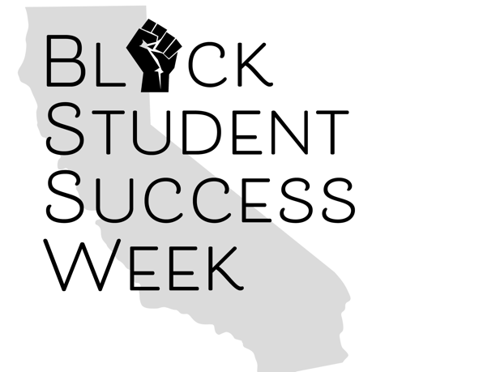

Black Student Success Week Funding Sources

**Potential Funding Sources:**

1. Student Equity Achievement Program
2. Associated Student Government
3. Categorical Funds (EOPS, CalWORKS, Foster Youth)
4. Rising Scholars
5. Mental Health
6. Foundation Funds
7. Umoja Funds
8. President’s Office